

# Hands-on Lab

# Create your own ToDo-list

## Description

In this demo you will create a web application with a ToDo-list. The web application will be public which means that everyone can use it, wherever they are located.

## 1. Create the application

1. Start navigate to http://bluemix.net in a browser.
2. Select ‘LOG IN’ then enter your log in information and press ‘SIGN IN’. You should be seeing  your dashboard view:  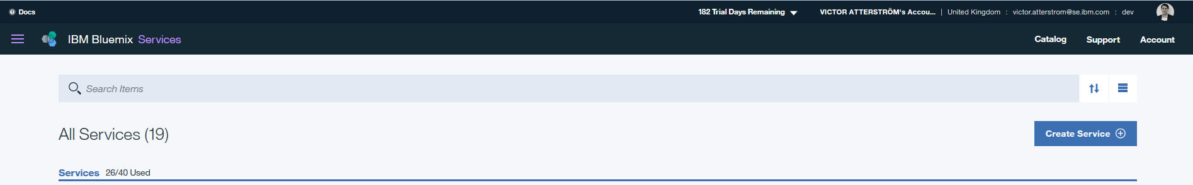
3. Select the ‘CATALOG’ view.
4. Locate the **SDK for Node.js** found in Cloud Foundry Apps under “Apps” section.

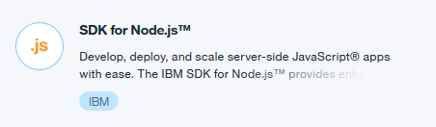

1. Click on it and give it a name. Click Create.    
   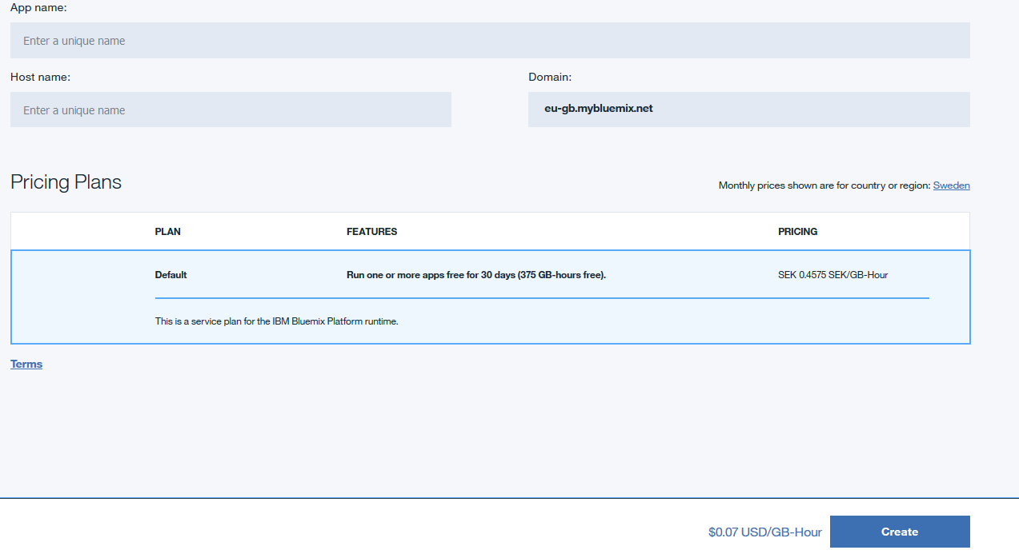
2. Wait for your application to start. If you want to see what is happening in the background, click on “Logs” in the left menu.s
3. View your newly created application by clicking “View app”.

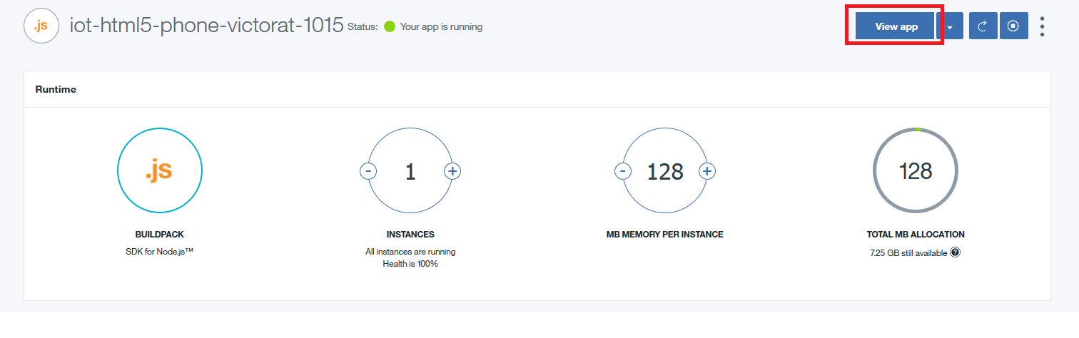

1. This is a basic “hello world” application. Now we need to update this application with the code for our todo list application.
2. Install a decent code editor (e.g. Notepad++ for Windows or TextWrangler for Mac) Windows: http://notepad-plus-plus.org Mac: http://www.barebones.com/products/textwrangler
3. Install Cloud Foundry command line Interface. The link for this is found under “Getting started” within your application page:

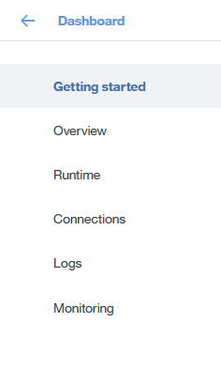  
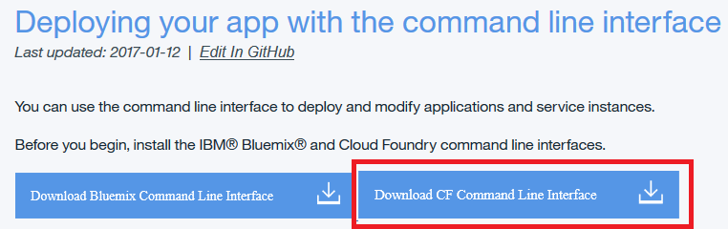

1. Next you need to download the code that we need for creating our website. Download it from below link by clicking on ”Download Zip” <https://github.com/IBM-Bluemix/todo-apps> (the following steps can also be done by simply using GIT: git clone https://github.com/IBM-Bluemix/todo-apps.git
2. Create a new folder in preferrably your Documents directory. Name the folder bluemixdemos\todo
3. Unzip your downloaded package and put it in your new bluemixdemos\todo folder.
4. Navigate down to the node directory and open the **manifest.yml** file with your text editor you downloaded before (Notepad++).
5. In this file you need to change **name** and **host**. Make this two the same name as you named your application in Bluemix.  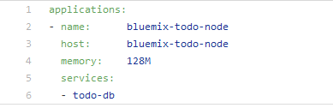
6. Save the file.
7. We have now downloaded the source code for our todo list application. For this application to work, we will need to store the todos in a database. So lets add one in Bluemix! Go back to your Bluemix application, and click the **Connections** tab:

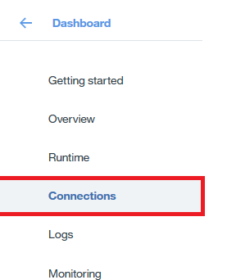

1. Next, click  
    
2. Locate the **Cloudant NoSQL** service under the Data and Analytics section (or just search for cloudant in the search felt at the top of the page). Click on it and name it **todo-db.** It's very important that you name it exactly this name, or else it won't work.
3. Open your **Command Prompt.** (You can just click on your Windows icon and search for it)
4. Now you need to locate to the right directory so you can start work with your application. You need to get all the way down to your N**ode-**folder in your bluemixdemos\todo directory. The easiest way to do it is to open your documents, go all the way down to the node-folder and right-click (see picture below where to right-click) in the upper felt and choose ”Copy address as text”.    
   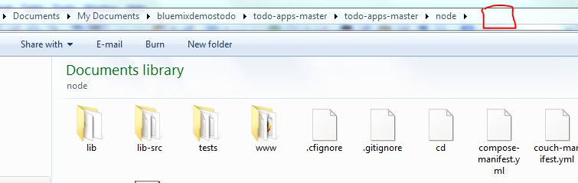
5. Go back in to the Command Prompt, start write ”cd ”(notice the blank space after cd) and then right-click in the upper border and choose ”Edit - Paste”. It will then look something like this:   
    Click Enter.
6. You are now in the right directory/folder and are ready to start log in and push the code to Bluemix.

## 2. Log in to Bluemix and push the code

You will write all this upcoming commands in the Command Prompt

1. Start with connecting to Bluemix. Write:   
   cf api <https://api.ng.bluemix.net> (if your application was created in the US region) or

cf api <https://api.eu-gb.bluemix.net> (if your application was created in the EU region)

1. Log into Bluemix with your account:   
   cf login
2. Wait for ”Email” to show up and write in your Bluemix registered email. Press enter
3. Wait for ”Password” to show up and write your Bluemix password. Press enter
4. If the login in succeeds you are now ready to push your application up to the Bluemix cloud.
5. To push your application, write below command and press Enter.   
   cf push
6. Wait until it succeeds and is up running. It may take a few minutes.
7. When it's done, go to your application *yourapplicationname*.mybluemix.net and try it out!

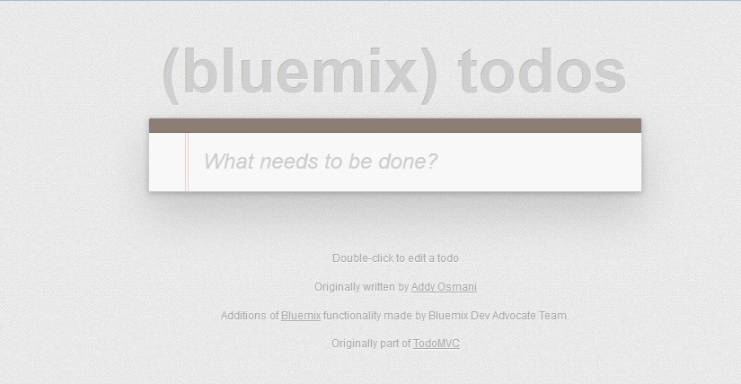

## 3. Exploring the database being used

1. Make sure you have made a todo list entry:

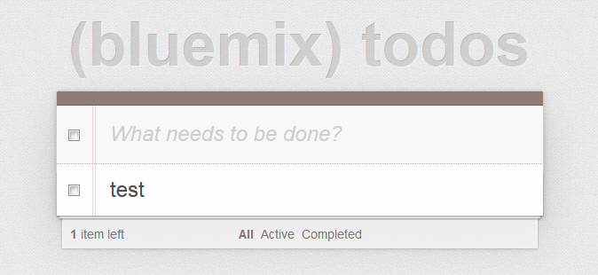

1. Go back to your Bluemix application tab and click on your Cloudant Database connection.

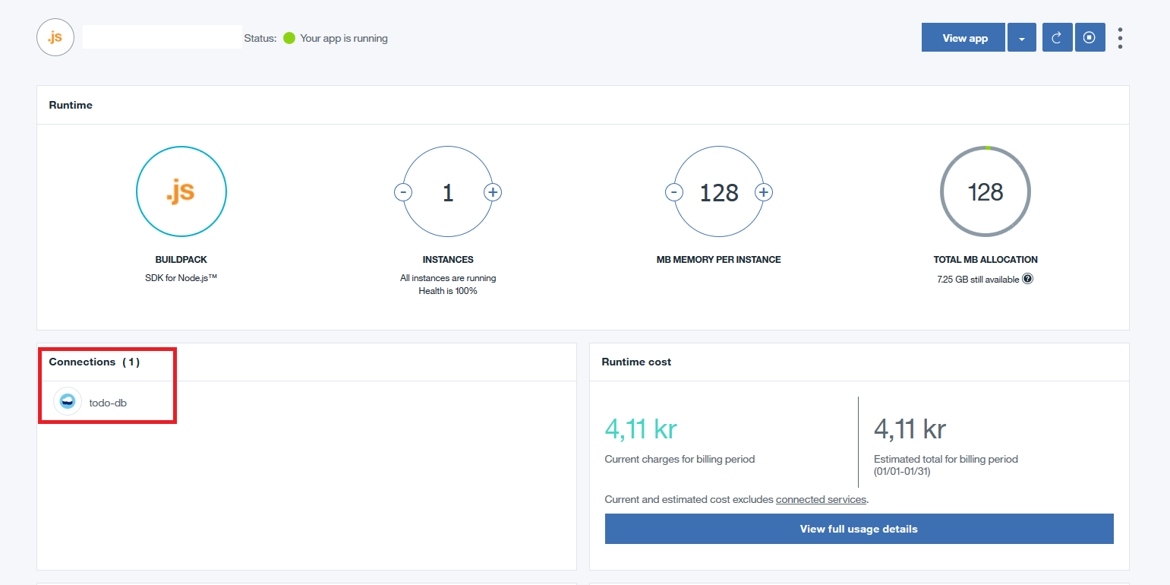

1. Click “Launch” on the next page to get into the management console of your database.   
   
2. Click on “Databases” and then on your todos database.  
   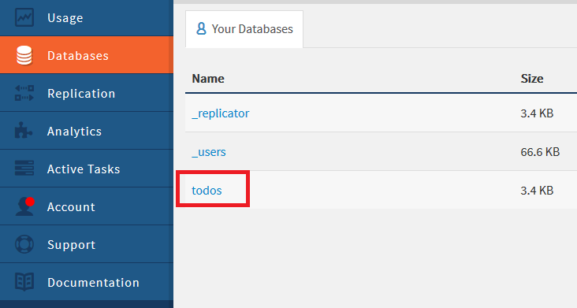
3. Next, click on the “pen” icon on one of your database entries:

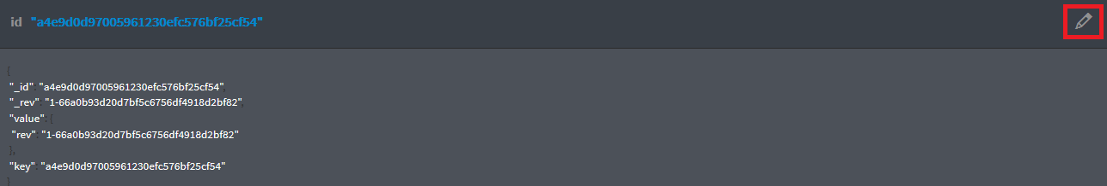

1. Here you can see the entry you made in your todo list application. Change the entry you made under “title” and then click **Save Changes.**

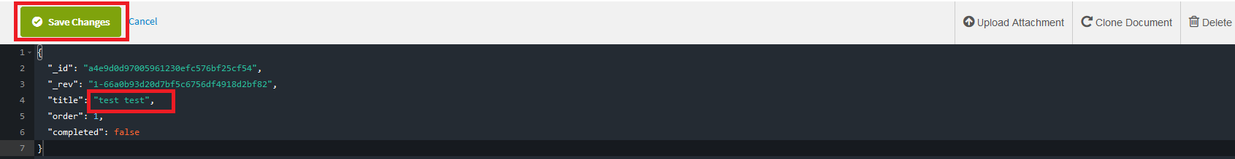

1. Go back to your todo list application, refresh the page and view the updated entry. You have now made a change via the browser, and also a change directly from within the database.

**Congratulations, you have now created a todo list application where you learned how to create a basic Bluemix runtime, update that runtime with code taken from Github, and explored how the data is stored in a database.**